Vicki's Maternity Leave

Please note that our nursery manager, Vicki, will be taking some annual leave to reduce her working days throughout October, November and December and she will begin maternity leave by Friday 8th December. Vicki plans to take a year's maternity leave to care for her daughter before returning to work in her full capacity.
Radka will take on the role of nursery manager, nursery teacher and designated safeguarding lead during Vicki's maternity leave, and Danielle will become deputy nursery manager and deputy designated safeguarding lead. They will be supported well by our administration officer (Karla), the rest of our leadership team (Shane and Amy), and our trustees. We are sure they will do a brilliant job and the transition will be very smooth.
Please use Karla's email address for contacting us (nursery@hythebay.kent.sch.uk) and Karla will forward your email to the relevant person if necessary. We recommend saving Karla's email address as a contact and avoiding using Vicki's email address until she returns from maternity leave.

Nursery Newsletter

Our latest newsletter has been added to our nursery website (www.hythebaynursery.co.uk) and will be displayed on the parents' board.

We have decided to stop emailing the newsletter out to parents as a number of parents have reported not receiving them in the past, as they have either ended up in junk mailboxes or there may have been unknown errors when sending them. This decision will also reduce the additional workload for Radka, Danielle and Karla when Vicki goes on maternity leave.

However, the newsletters are always uploaded to the nursery website and displayed on the parents' board by the end of each term. The opening and term dates are also available on the nursery website homepage and on the Parents' Newsletters page. They are usually shared in our facebook group too.

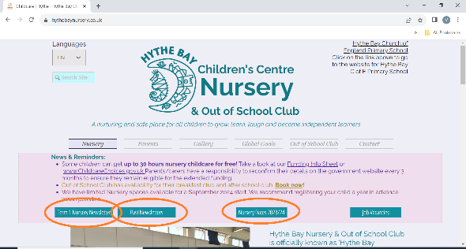

Please don't hesitate to contact us if you have any questions.
Thank you.

Kind regards,
Hythe Bay Nursery Team

